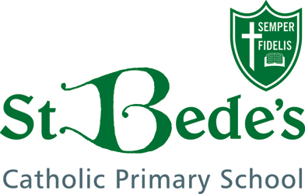

ACHIEVING EXCELLENCE TOGETHER
Inspiring independent learners with Jesus by our side

Foundation Stage

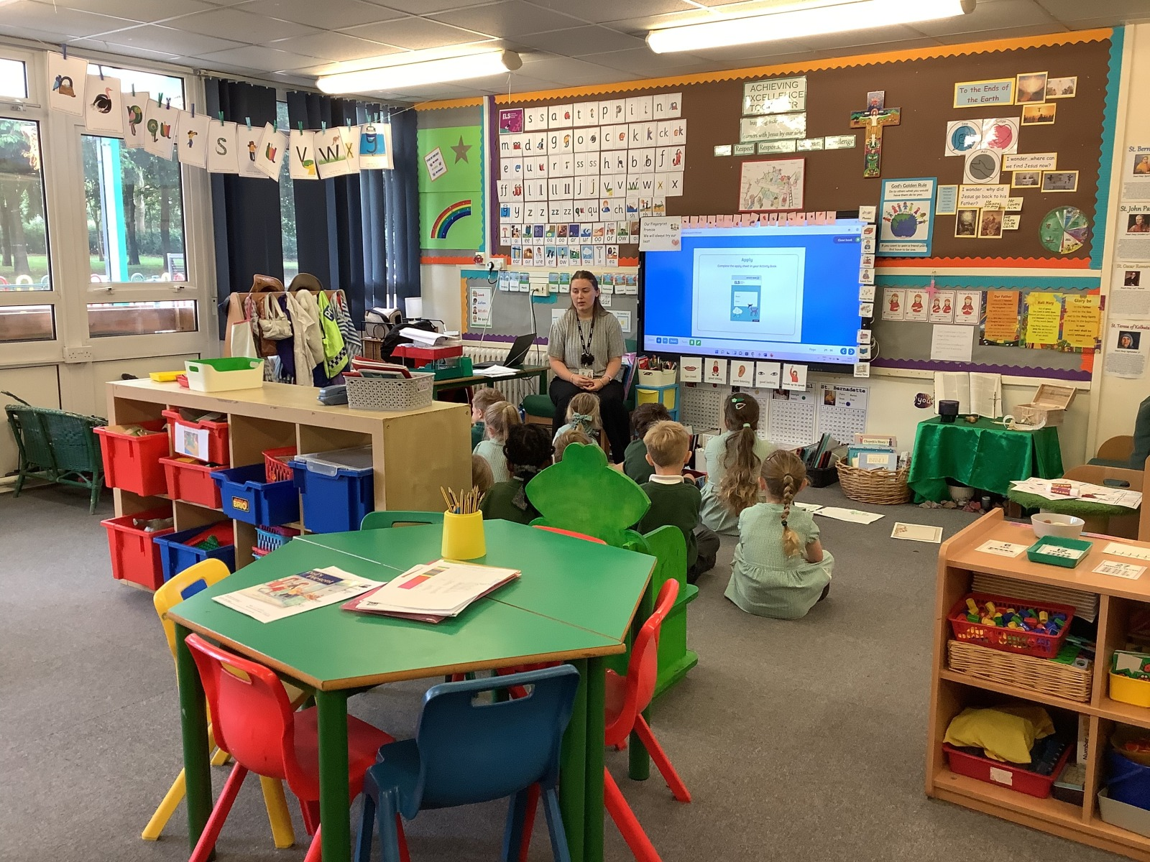
All About Me Booklet

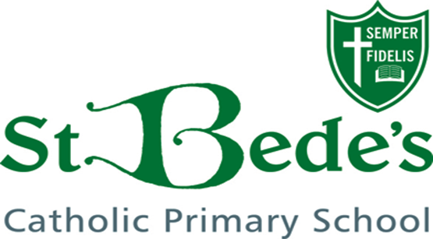

Welcome to St. Bede’s!
We are looking forward to welcoming you and your family into our school.
This booklet enables us to find out more about your child, which will help us to ensure a happy and secure start.
Please help your child fill in this booklet. They can draw pictures, cut out pictures from magazines or stick in photos.
There is a page for parents and carers to answer, which includes some important information that we need at school to help your child settle.
Thank you.
Miss Welch
and the Early Years Reception Team

What is your name?

How old are you?

Draw a picture of yourself

Who is in your family?

We are here to help you.
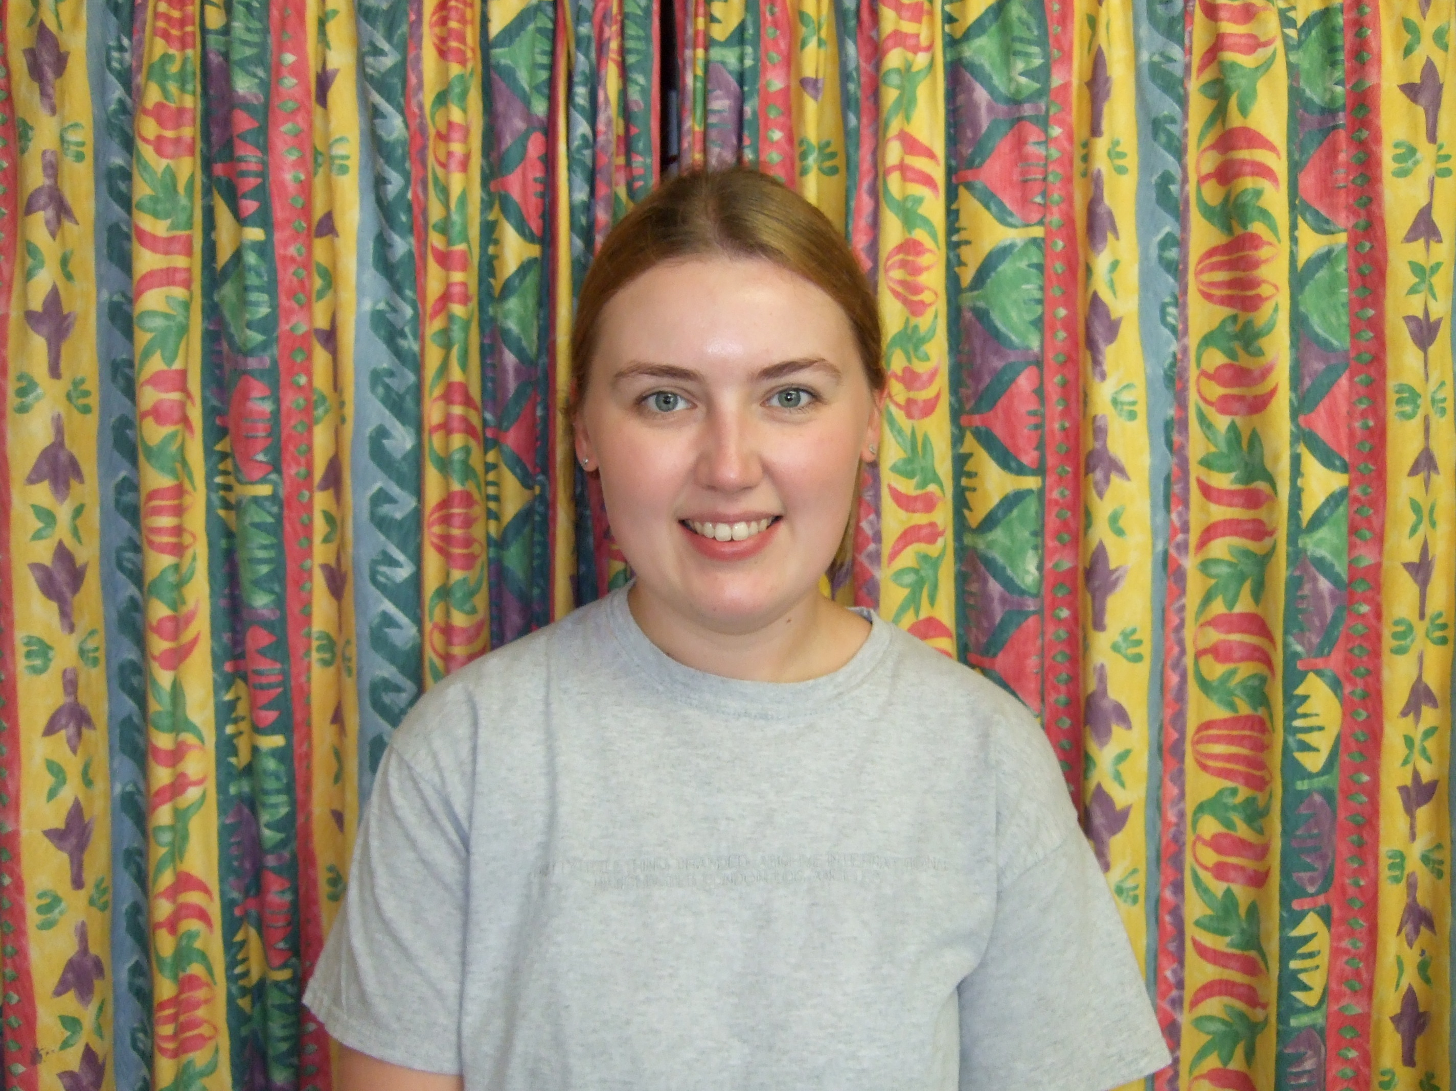
I am your new teacher, Miss Welch.
My favourite story is ‘Giraffes Can’t Dance’. My favourite nursery rhyme is ‘Miss Polly’. My favourite food is chicken pasta and I love mango. I enjoy going on long walks with my dog Molly.
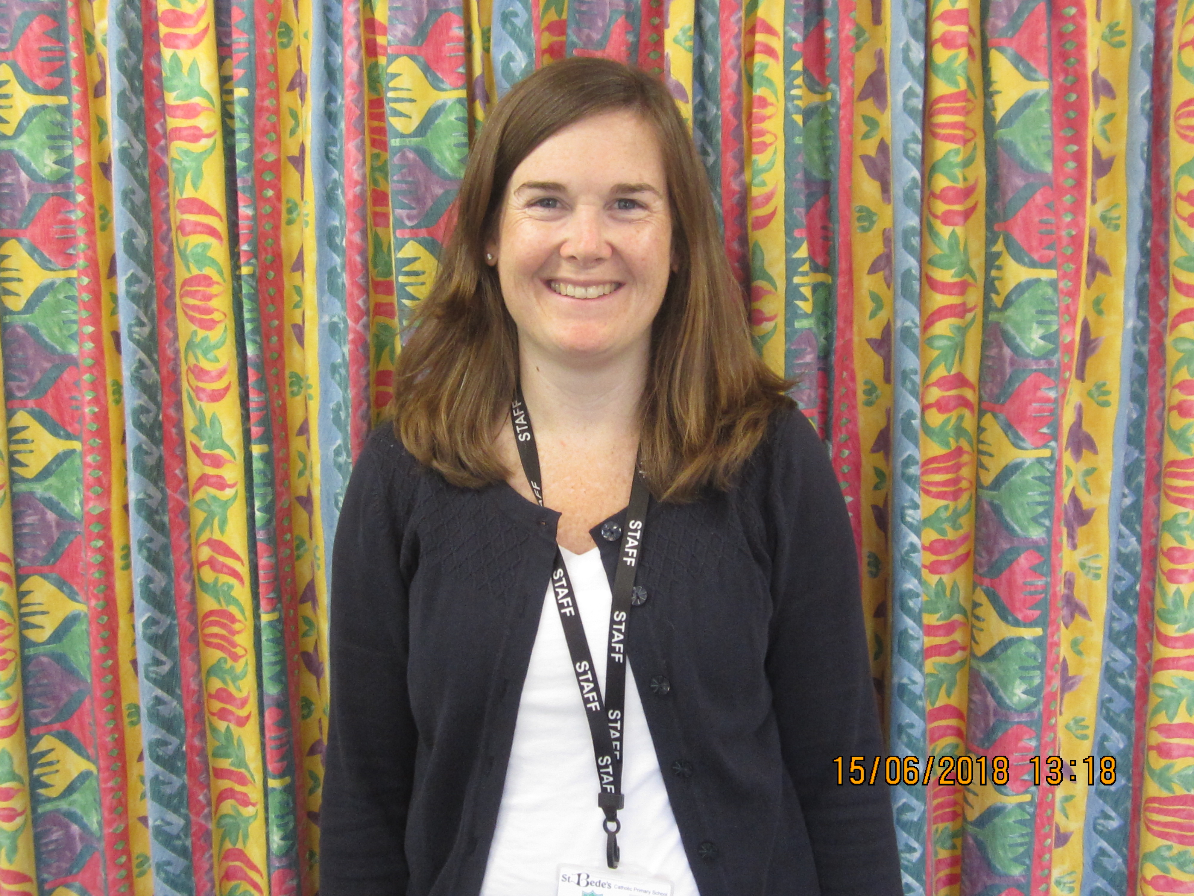
I am your new teaching assistant Miss Robson.
My favourite story is ‘Oi Frog’. My favourite nursery rhyme is ‘Twinkle Twinkle’. My favourite food are blueberries.
Tell us about things that you like.
What are your…
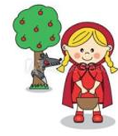
…favourite stories? _________________________________________ _________________________________________ _________________________________________ _________________________________________

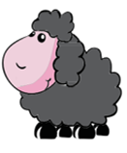
…favourite rhymes?
_____________________________________
_____________________________
_____________________________

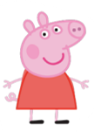
…favourite TV characters? _____________________________________ _____________________________________ _____________________________________ _____________________________________

 | I like | I don’t like
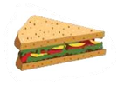
Food

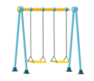
Places to visit

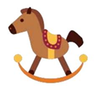
Things to play with

Things that comfort me
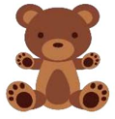

Parent/Carer section.

Do you have any concerns about your child?

Vision:

Speech:

Hearing:

Is there any additional information or any issues that you would like us to be aware of?

Thank you for sharing. We are looking forward to September and getting to know you more!

